Antonio Rosado

Prof. Chien

IOOP Section #4

Lab #7

**By submitting this work, I certify that this assignment is my own work, and that I have not copied in part or whole from online sources or plagiarized the work of other students.**

**4.X4-4.X5**

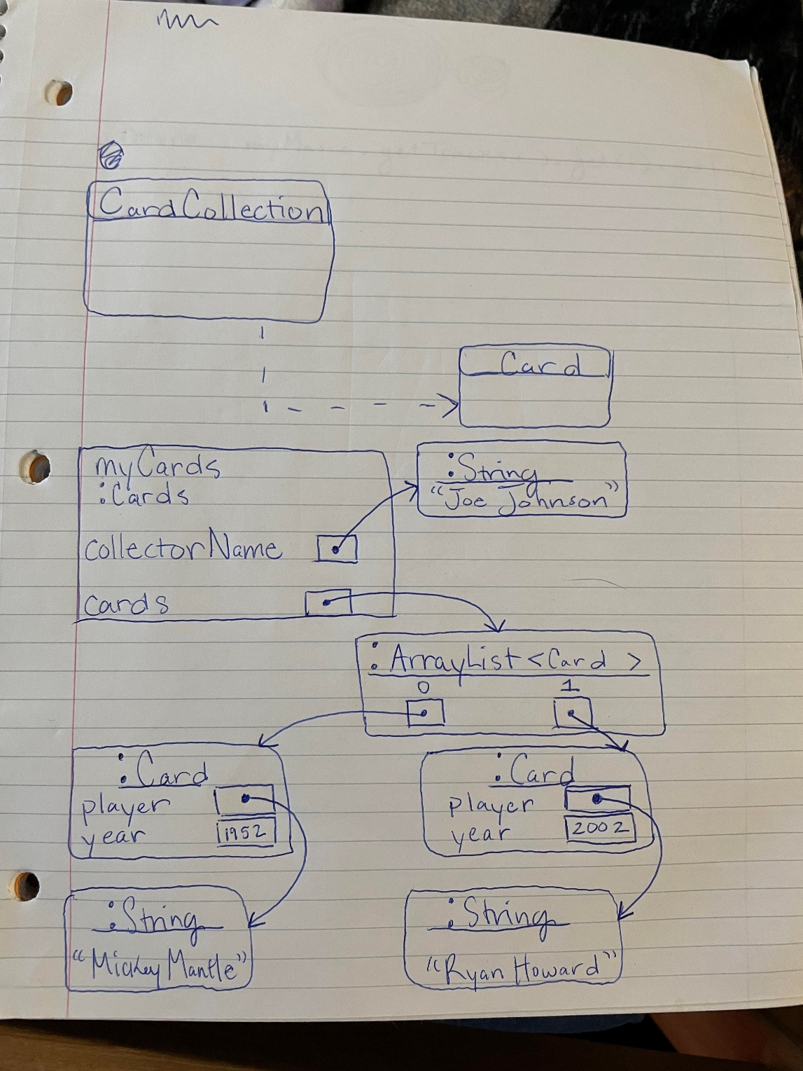

**README**

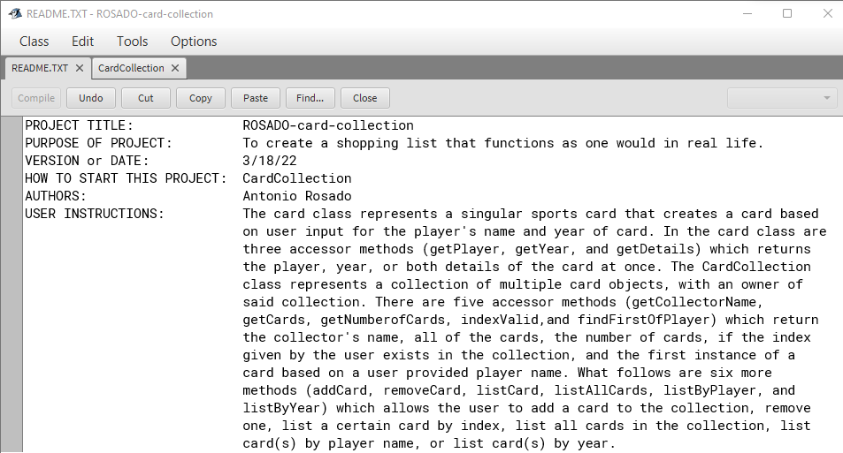

**4.X6**

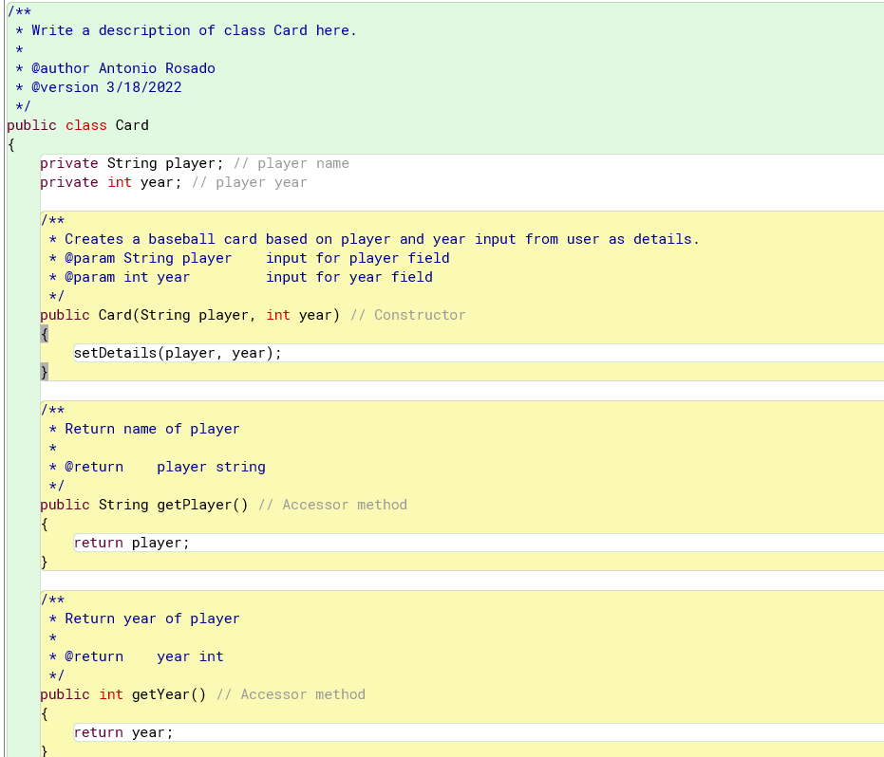

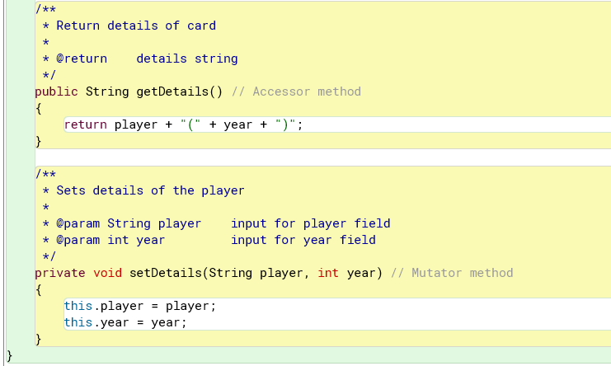

**4.X7**

